

Accessibility Plan

This policy operates in accordance with the teachings of the Catholic Church

and our Academy Mission Statement.

This policy was updated in the Lent Term 2020.

The teachings of the Catholic Church are detailed in the Catechism of the Catholic Church published by the Catholic Truth Society, London, an Official Publisher to The Holy See.

The Academy Mission Statement is located on page 2 of this policy, and is displayed in our academy, and on our website.

Approved by: | The Local Governing Body | Date: January 2020
Last reviewed on: | January 2020
Next review due by: | January 2023

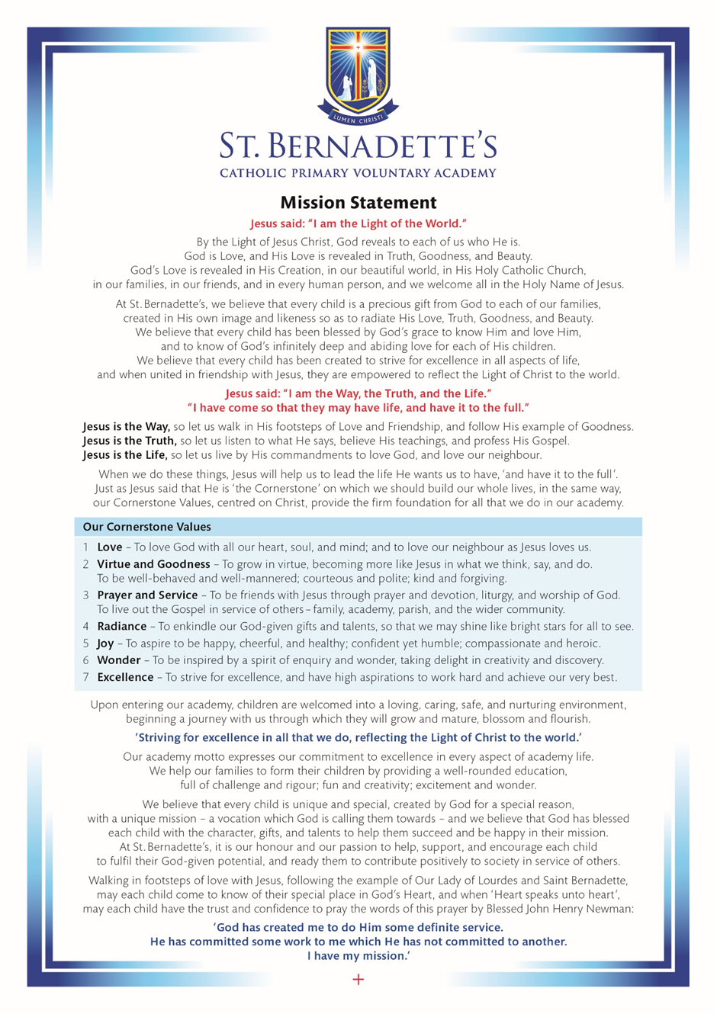
Contents
1. Aims 3
2. Legislation and guidance 4
3. Action plan 5
4. Monitoring arrangements 9
5. Links with other policies 9
Appendix 1: Accessibility audit 10

…………………………………………………………………………………………………………………………….

1. Aims
Schools are required under the Equality Act 2010 to have an accessibility plan. The purpose of the plan is to:
- Increase the extent to which disabled pupils can participate in the curriculum
- Improve the physical environment of the school to enable disabled pupils to take better advantage of education, benefits, facilities and services provided
- Improve the availability of accessible information to disabled pupils
Our school aims to treat all its pupils fairly and with respect. This involves providing access and opportunities for all pupils without discrimination of any kind. We take guidance from the St Thérèse of Lisieux Multi Academy Trust - https://www.stl-cmat.org.uk/

The plan will be made available online on the school website, and paper copies are available upon request.
Our school is also committed to ensuring staff are trained in equality issues with reference to the Equality Act 2010, including understanding disability issues.
The school supports any available partnerships to develop and implement the plan, including the Local Authority Disability Team
http://www.northlincslocaloffer.com/what-are-special-educational-needs-and-disability/#1523263170549-b5ba0b88-05f07e41-5ed41493-54ca
Our school’s complaints procedure covers the accessibility plan. If you have any concerns relating to accessibility in school, this procedure sets out the process for raising these concerns.
We have included a range of stakeholders in the development of this accessibility plan, including: pupils, parents, staff and governors of the school.

2. Legislation and guidance
This document meets the requirements of schedule 10 of the Equality Act 2010 and the Department for Education (DfE) guidance for schools on the Equality Act 2010.
The Equality Act 2010 defines an individual as disabled if he or she has a physical or mental impairment that has a ‘substantial’ and ‘long-term’ adverse effect on his or her ability to undertake normal day to day activities.
Under the Special Educational Needs and Disability (SEND) Code of Practice, ‘long-term’ is defined as ‘a year or more’ and ‘substantial’ is defined as ‘more than minor or trivial’. The definition includes sensory impairments such as those affecting sight or hearing, and long-term health conditions such as asthma, diabetes, epilepsy and cancer.
Schools are required to make ‘reasonable adjustments’ for pupils with disabilities under the Equality Act 2010, to alleviate any substantial disadvantage that a disabled pupil faces in comparison with non-disabled pupils. This can include, for example, the provision of an auxiliary aid or adjustments to premises.
This policy complies with our funding agreement and articles of association.

3. Action plan
This action plan sets out the aims of our accessibility plan in accordance with the Equality Act 2010. At St. Bernadette’s our Mission is at the heart of everything we do and as such we will ensure that every child achieves their God given potential.

Aim | Current good practice  Include established practice and practice under development | Objectives  State 1.short, 2.medium and 3.long-term objectives | Actions to be taken | Person responsible | Date to complete actions by | Success criteria
Ensure access to the curriculum for pupils with a disability | Our school offers a differentiated curriculum for all pupils. | 1.Lesson plans identify context groups and how tasks are differentiated.  2.Long term plans will reflect the diversity of our cohort.  3.Curriculum development will ensure a wide balanced curriculum for all. | Lesson plans will be scrutinised as part of lesson observations.  As part of the curriculum review plans will be scrutinized by subject leaders to ensure they meet the needs of all children.  As part of the curriculum review plans will be scrutinized by subject leaders to ensure they meet the needs of all children. | Class teachers and subject leaders  Class teachers, subject leaders and senior leadership | Termly  Cycle A by Pentecost Term 2020  Cycle B by Pentecost Term 2021 | Context groups will be identified on all plans.  Lesson plans will include differentiated tasks and adaptations where necessary.  Long term plans will reflect the curriculum intent and the academy mission statement.  The curriculum will reflect the curriculum intent and the academy mission statement.
Ensure access to the curriculum for pupils with a disability | We use resources tailored to the needs of pupils who require support to access the curriculum. | 1.Support strategies are recorded in individual SEN running records.  2.Child voice will be an integral part of plan, do, review implementation.  3. Parent/carer voice will be an integral part of plan, do, review implementation.  3.Pupil progress meetings will incorporate discussions on resourcing for disabilities and any needs highlighted. | Running records will be updated at least every term by the class teacher, in consultation with the SENTA and SENCO.  As part of the running record children will complete a one page profile. Their progress and targets will be discussed with the child and their parent/carers and their views recorded and taken into account.  Pupil progress meetings will take place termly with the class/set teacher and their progress leader. | Class Teachers, SENTA,  SENCO,  Class Teachers, SENTA,  SENCO  Class Teacher, Pupil Progress Leaders, Headteacher | Termly | Support strategies will be recorded on the pupil’s Running Record and updated termly.  Children will complete a one page profile termly which will accompany and inform their running record.  Meetings will be held with parents each term where their views will be recorded and impact upon the running record for that child.  Needs will be identified.  Discussions on resourcing will take place.  Steps will be taken to ensure resources are available.
Ensure access to the curriculum for pupils with a disability | Curriculum resources include examples of people with disabilities. | 1.Where ever possible resources will be used that reflect the diversity of the wider community.  2,Diversity will be considered when resourcing topics, PE, PsHE and literature.  3.As a whole school approach diversity will be considered when purchasing any equipment for the school. | Subject leaders will actively seek out resources that include positive representations of minority groups and disabilities across the whole curriculum. | Class teachers, subject leaders | Cycle A by Pentecost Term 2020  Cycle B by Pentecost Term 2021 | Resources will reflect the diversity of the wider community
Ensure access to the curriculum for pupils with a disability | Curriculum progress is tracked for all pupils, including those with a disability. | 1.Context groups are tracked using OTrack.  2.Discussions will be carried out to establish if we can split the context groups further for different disabilities.  3.Creation of OTrack tracking or academy tracking of children with disabilities. | N Baldwin (data lead) will issue data sheets which will show the progress of context groups against the general school population.  Leadership team will secure training in FFT to further identify and analyse context groups.  Pupils will be tracked on an individual basis. | Class teachers, data lead, senior leaders. | Core subjects – each half term.  Noncore subjects termly. | Every class teacher will be fully informed of the progress of the context groups within their class/set.  Children will make at least good progress and achieve their targets.
Ensure access to the curriculum for pupils with a disability | Targets are set effectively and are appropriate for pupils with additional needs. | 1.Support strategies and targets are recorded in individual SEN running records.  2.Child voice and parent voice will be an integral part of plan, do, review implementation.  3.Individual review meetings will incorporate discussions on effective targets for disabilities and any needs highlighted. | Running records will be updated at least every term by the class teacher, in consultation with the SENTA and SENCO. Targets will be assessed and new targets created.  As part of the running record children will complete a one page profile. Their progress and targets will be discussed with the child and their parent/carers and their views recorded and taken into account. Medical conditions, family circumstances and disabilities which may affect the child’s learning will be discussed and recorded. | Class Teachers, SENTA,  SENCO, | Termly | The impact of a child’s SEND on their education and subsequent progress will be reduced. Children will achieve their targets.
Ensure access to the curriculum for pupils with a disability | The curriculum is reviewed to ensure it meets the needs of all pupils. | 1.Lesson plans identify context groups and how tasks are differentiated.  2.Long term plans will reflect the diversity of our cohort.  3.Curriculum development will ensure a wide balanced curriculum for all. | As part of the curriculum review plans will be scrutinized by subject leaders to ensure they meet the needs of all children. | Class teachers,  subject leaders, senior leadership | Cycle A by Pentecost Term 2020  Cycle B by Pentecost Term 2021 | The curriculum will reflect the intent and mission statements.
Improve and maintain access to the physical environment | The environment is adapted to the needs of pupils as required.  This includes:  - Ramps  - Corridor width  - Disabled parking bays  - Accessible toilets and changing facilities  - Library shelves at wheelchair-accessible height  - Well lit corridors  - Use of colour to aid visibility | 1. Individual pupils will be consulted as to their mobility around the academy and what they need in order to ensure fair access.  2.Outside agencies who work with our children will be consulted as to how best support our children.  3.Long term development plans will take into consideration disabled access for children and their families and visitors to the academy. | Children will be consulted as part of the Running Record cycle.  Discussions will take place with agencies already involved and agencies sought out as a new need arises.  All disability groups will be considered and expert advice sought. | Class Teachers, SENTA,  SENCO,  outside agencies  Head teacher.  Disability team. | Termly  As and when a new development begins | Every child will be able to access all areas in and around the academy safely.
Improve the delivery of information to pupils with a disability | Our school uses a range of communication methods to ensure information is accessible. This includes:  - Internal signage  - Large print resources  - Braille  - Pictorial or symbolic representations  - Makaton | 1.Individual pupils and their families will be consulted as to their communication needs and what they need in order to ensure fair access.  2.Outside agencies who work with our children will be consulted as to how best support our children.  3.Staff training will reflect the communication needs of our cohorts. | SEND review meetings will be set up by the SENCO and Running Records completed taking into account all stakeholders views including the child, teachers, support staff and outside agencies.  The SENCO will identify and implement training as required. | Class Teachers, SENTA,  SENCO,  outside agencies  SENCO | Termly or when a new need is identified.  Annually | Information in the academy will be shared in such a way as to ensure it is accessible to all regardless of any disability.

4. Monitoring arrangements
This document will be reviewed every 3 years, but may be reviewed and updated more frequently if necessary.
It will be approved by Mr M Strong and the academy governing body.

5. Links with other policies
This accessibility plan is linked to the following policies and documents:
- Risk assessment policy
- Health and safety policy
- Special educational needs (SEN) information report
- Supporting pupils with medical conditions policy
- Intimate Care Policy

Appendix 1: Accessibility audit

Feature | Description | Actions to be taken | Person responsible | Date to complete actions by
Number of storeys | 1` | None
Corridor access | Corridors are accessible for all users | Corridors must be kept clear and well-lit at all times. | All Staff | Ongoing
Lifts | 0 | None
Parking bays | 1 disabled parking bay | Parking bay is clearly labeled with reminders to parents and visitors that it is for the use of disabled badge holders only. | Head teacher | Ongoing
Academy driveway | There are separate driveways for pedestrians and vehicles. | New developments to ensure entrances are clearly visible for all. | Head teacher | Ongoing
External signage | External signage is an area for development. | New signage to be clear and explicit. | Head teacher  Leadership team | Ongoing
Entrances | The majority of entrances are accessible to all users. Where the access is not universal (playground exit from class 8, one entrance to class 7) an alternative entrance is available. | New developments will ensure that all entrances have universal access. | Head teacher | Ongoing
Ramps | All classrooms except class 8 have ramp access where needed i.e. different floor levels. They are accessed and maintained to a high standard. | New developments will ensure that all entrances have universal access. | Head teacher, caretaker | Ongoing
Toilets | One disabled toilet. | Reviewed to ensure it meets the needs of the academy population. | Head teacher | Annually
Reception area | The reception area is not currently accessible to all due to the height of the desk. | Office staff will be sensitive to visitors needs and ensure they respond to individual needs sensitively.  Developments will take into account all disabilities. | Headteacher  Office Staff | Ongoing
Internal signage | The academy does not have many internal signs due to the size of the site. | Signage will be discussed and developed. | Head teacher  Leadership team | Ongoing
Emergency escape routes | All areas have an emergency escape route which is accessible to all. Class 8 is compromised with steps from the door directly from the class to the playground. | Exits reviewed and maintained. New developments will ensure all routes are universally accessible. | Head teacher | Ongoing

